EXPERIMENT – 14
Perform Perspective Transformation on the Given Image Using Python and OpenCV
Aim
To perform perspective transformation on an image using Python and OpenCV.
Procedure
- Import the OpenCV and NumPy libraries.
- Read the input image using cv2.imread().
- Check whether the image is loaded successfully.
- Define four corner points in the original image.
- Define four corresponding destination points.
- Calculate the perspective transformation matrix using cv2.getPerspectiveTransform().
- Apply the transformation using cv2.warpPerspective().
- Display the original and perspective-transformed images.
Program
import cv2
import numpy as np

image = cv2.imread("image.jpg")

if image is None:
print("Image not found!")
else:
rows, cols = image.shape[:2]

points1 = np.float32([
[0, 0],
[cols - 1, 0],
[0, rows - 1],
[cols - 1, rows - 1]
])

points2 = np.float32([
[50, 50],
[cols - 50, 0],
[0, rows - 50],
[cols - 1, rows - 1]
])

matrix = cv2.getPerspectiveTransform(
points1, points2
)

transformed = cv2.warpPerspective(
image, matrix, (cols, rows)
)

cv2.imshow("Original Image", image)
cv2.imshow("Perspective Transformation", transformed)

cv2.waitKey(0)
cv2.destroyAllWindows()
Sample Input
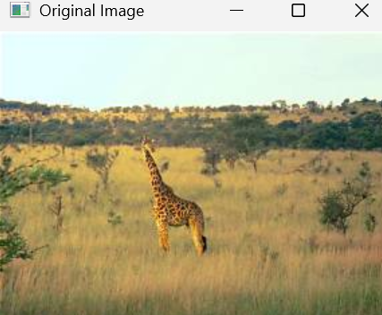
Sample Output
- 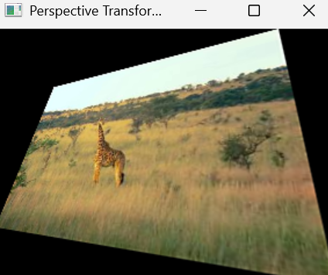
- Perspective-transformed image with altered perspective.
Result
Thus, perspective transformation was successfully performed on the image using Python and OpenCV.

